**Chromium OS & Google Chrome OS**

**Google Chrome OS**

**C:\Users\TECHAHOY\Desktop\chrome_logo.gif**

Google Chrome OS is a linux based operating system which the developers started building in 2009 after seeing the growing popularity of power consumption netbooks. This is a browser based operating system and is meant mainly to power user’s online experience. This operating system is inspired from the design of its successful browser Google Chrome.

Here is a screenshot of how Google Chrome OS actually looks:

**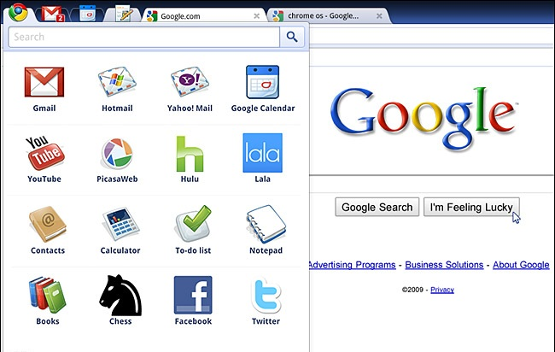**

Chrome OS is available only to Google approved vendors which is mainly Samsung and Acer.  
The Operating system is shipped along with the Chromebooks. At a conference at Google HQ, the OS took 7 seconds to load which Google promised that will be optimised.

The best part of this OS is that the operating system gets auto updated and there is no need for users to worry about anything. This project was focussed towards the web as people spend most of their time online.

Chrome OS is not a open source project but is developed by the employees of Google alone.

If we take security into account, Google claims that Chrome OS is very secure due to its sandbox features available to block malwares and also boasts of verified boot features.

Breaking the convention in design of laptops, Chromebooks have replaced the Caps Lock key with a Search key.

**Chromium OS**

**C:\Users\TECHAHOY\Desktop\customLogo.gif**

Chromium OS and Chrome OS have the same base except for the difference that Chromium OS is open source whereas Chrome OS is not. Google released Chrome OS source code to developers in 2009 to make it more robust.

Here, the auto-update feature is disabled since the user must not lose the change he made to the OS after updating.

This operating system and its source codes are available for download at [www.chromium.org](http://www.chromium.org)

If you are a developer, you can catch the Chromium OS users at   
irc.freenode.net/#chromium-os-users

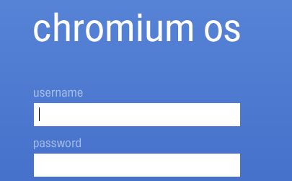Here is a screenshot showing Login screen in Chromium OS  
  
**A few differences**Google Chrome OS include some binary packages which are not allowed to be included in the Chromium OS project. A list showing the differences:

* + Adobe Flash
  + Adobe PDF
  + Netflix Instant
  + Google Talk
  + 3G Cellular support (but work is on going to address this)
  + Older versions of Chrome OS might contain proprietary Synaptic Touchpad Drivers
    - All recent releases (R20+) should be using the open source CMT driver
    - NB: open source drivers have long existed and are automatically used in Chromium OS

(source: chromium blog)

Google Chrome OS & Chromium OS is a good initiative by Google but considering the fact that you can do almost everything what Google promises in other operating systems like Windows or the Linux distros rather than sticking to single browser all the time. But still, it is not the time to say that Chrome OS cannot make a revolutionary change. It all depends on the user’s taste.